**PROJECT SUMMARY**

Specifications of the processes taken for the individual project and a roadmap for future projects:

**STRUCTURE**

1. Generate the necessary folders for the project and structure a main folder and a folder for the app.
2. Create a repository on GitHub and run git init in the local folder to connect the entire project to an existing repository and maintain version control.
3. Create a virtual environment with Python 3.12 and PyCharm where we can set up a unique environment for this project and its libraries. Basic file structure.

**Commands:**

* python -m pip install Django
* django-admin startproject Mysite (FolderToDeploy)
* python3.12 manage.py migrate
* python3.12 manage.py runserver

Basic project creation DONE. Structure for generating volume in Docker created.

**DOCKER STRUCTURE**

Summary of the necessary commands to set up a standard Docker environment:

**Commands:**

* docker build -t <image_name> (Create from Dockerfile)
* docker images (List images loaded locally)
* docker run -d (Run server in the background)
* docker ps (Check containers currently running)
* docker ps -a (Check container history)
* docker stop / docker start / docker restart / docker rm <container_name>
* docker exec -it <container_name> /bin/bash (or sh) (Container terminal)
* docker stats (Shows resource usage)
* docker inspect <container_name> (Detailed container information)
* docker system prune (Clean up unused images, volumes, and containers)

1. Create a Dockerfile for the Python environment with version 3.9

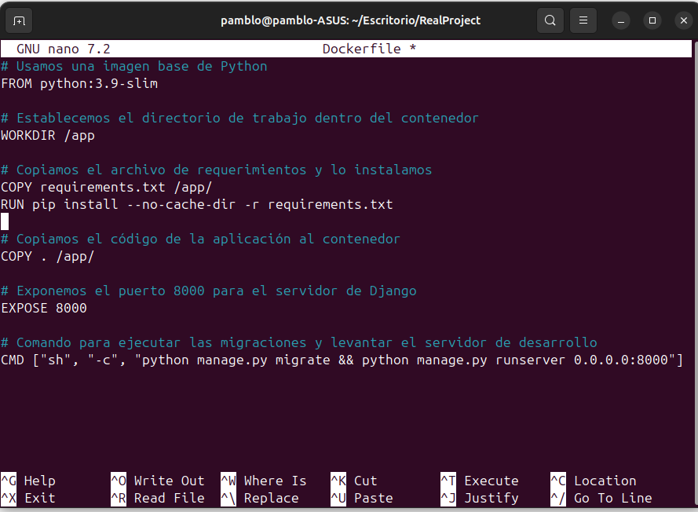

1. Create a requirements.txt for Django dependencies with the following information:

Django>=4.0,<5.0

1. we can now build the image with the following command:

-docker build -t django-app . (IMPORTANT END . TO SET FOLDER)

-docker images (We can now view an image prepared for Django)

1. Now we can run container exposed on port 8000 with new volumen shared with local copy of application

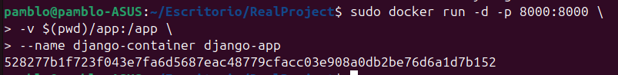

CHECK YOU ON CHROME LOCALHOST:8000 and enjoy your APP